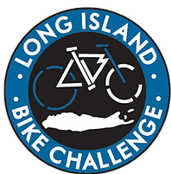

Dear recipient

On Sunday, August 6, 2023 I am riding my bike to battle cancer! I will be taking on the challenge of bicycling _____ miles in the Long Island Bicycle Challenge (LIBC) and I need your support.

The LIBC www.lichallenge.org challenges participants to bike across Long Island in order to raise money for medical research to defeat cancer, melanoma, and related diseases in order to improve the lives of affected patients and their families. Monies raised are donated to Feinstein Institute for Medical Research - the research arm of the Northwell Health System - and is a growing force in research innovation, imagination and discovery. Since 2012, LIBC riders have raised over $325,000 to beat cancer!

Please make a secure donation today!
You can donate online directly to my efforts at https://www.lichallenge.org/rider-and-or-team-donation. Please click the “donate” button next to my name.

Your generous donation in support of my efforts to defeat cancer is most appreciated.

If you prefer to write a check Please make checks payable to: Long Island Bike Challenge.
You can mail directly to: (Please indicate on check my name.)
Long Island Bike Challenge
1366 Odell Street
Wantagh, NY 11793

Thank you for supporting my efforts in the fight against cancer and disease.

Sincerely,

Your name

